Muhammad Kaleem

56614

***LAB TASK NO 8***

***Code using link list:***

#include<iostream>

using namespace std;

class Node {

private:

int data;

Node *next;

public:

Node() {

data = 0;

next = NULL;

}

Node(int value) {

data = value;

next = NULL;

}

void setData(int value) {

data = value;

}

void setNext(Node *link) {

next = link;

}

int getData() {

return data;

}

Node* getNext() {

return next;

}

};

class Stack {

private:

Node *head;

int top;

public:

Stack() {

head = NULL;

top = -1;

}

void push(int data)

{

Node* temp = new Node(data);

if (head == NULL)

{

head = temp;

}

else

{

temp->setNext(head);

head = temp;

}

top++;

}

void pop()

{

if (head == NULL)

{

cout << "Stack Empty" << endl;

return;

}

else

{

Node* temp = head;

head = head->getNext();

delete temp;

top--;

}

}

bool isEmpty() {

return head == NULL;

}

void print()

{

if (head == NULL)

{

cout << "Stack is empty" << endl;

return;

}

Node* temp = head;

cout << "Stack elements:\n";

while (temp != NULL)

{

cout << temp->getData() << " - ";

if(temp->getData() % 2 == 0)

{

cout << "Even" << endl;

}

else

{

cout << "Odd" << endl;

}

temp = temp->getNext();

}

cout << endl;

}

};

int main() {

Stack s;

s.push(10);

s.push(20);

s.push(30);

s.print(); //adding stack

s.pop();

s.print(); // deleting last element

return 0;

}

***Output:***

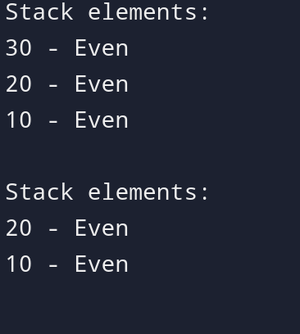

***Code using array:***

#include<iostream>

using namespace std;

class Stack {

private:

int arr[5];

int top;

public:

Stack()

{

top = -1;

}

void push(int data)

{

if (top >= 4)

{

cout << "Stack Overflow" << endl;

}

else

{

top++;

arr[top] = data;

}

}

void pop()

{

if (top == -1)

{

cout << "Stack Underflow" << endl;

}

else

{

cout << "Popped: " << arr[top] << endl;

top--;

}

}

bool isEmpty()

{

return top == -1;

}

void print()

{

if (top == -1)

{

cout << "Stack is empty" << endl;

return;

}

cout << "Stack elements:\n";

for (int i = top; i >= 0; i--)

{

cout << arr[i] << " - ";

if (arr[i] % 2 == 0)

{

cout << "Even" << endl;

}

else

{

cout << "Odd" << endl;

}

}

cout << endl;

}

};

int main() {

Stack s;

s.push(10);

s.push(20);

s.push(31);

s.push(40);

s.push(50);

s.print();

s.pop();

s.print();

return 0;

}

***Output:***

